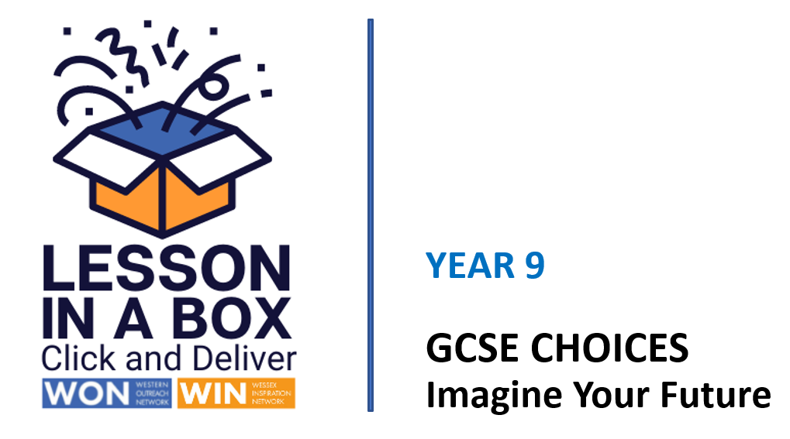

Delivery Notes

Session | Time  20 minutes
Session Objectives:

- What are GCSE’S and how do I choose them?
- Can I begin to identify the steps I need to take to choose my GCSE’S?
- What could I possibly do after school or college?

Learning Outcomes:

1) Can identify the process of choosing GCSE options.
2) Can identify future aspirations and skills.
3) Can identify a possible progression path and the different options available.

Resources

White Board
Teacher delivery via Power Point
Ikigai worksheet

Assessment/Pupil progress

Verbal feedback and response to Q&A

Take-Home Task

Suggest research into GCSE options using further links provided.

Please complete feedback form.
WIN Lesson in a Box - Staff Feedback (Page 1 of 2) (office.com)

 | Time | Activity | Purpose
INTRODUCTION | 0-2 mins  3-9 mins | Slides 1/2/3  Welcome the students and introduce the session.  Slide 4  Ask for a show of hands to gauge where students are with their choices.  Slide 5  Read slide and stress that students are now more in control of their learner journey.  Slide 6/7  Introduce Ikigai activity and the concept of a ‘Future You’.  Slide 8/9  Show Ikigai example - ask students to complete the worksheet and discuss results.  Slide 10  Discuss the jobs of the future graphic.  What job could the students invent for themselves? | Gauge student confidence and knowledge of their GCSE choices.  To demonstrate the broader range of transferable GCSE skills.  To demonstrate and discuss thinking big, living with purpose, identifying skills, interests, and passions to help guide GCSE choices.  To demonstrate the fast pace of jobs market and identify future aspirations.
DEVELOPMENT | 10-12 mins  12-14  15-17  mins | Slide 11/12  Watch GCSE facts video.  Slide 13  Introduce the concept of progression.  Emphasise that learning is life-long and that they may come back to learning or complete a degree or further study later in life.  Slide 14  Talk through the slide and discuss the different learning options available at each level. Emphasise that you can do an apprenticeship and gain a degree and talk through the progression from BA to MA to the possibility of gaining a PHD.  Slide 15  Talk though slide and emphasise careers support available to students.  Slide 16-24  Introduce and play jobs quiz - ask students to consider whether their skills and possible GCSE choices might fit any of the jobs or professions?  Slide 25-26  Play true or false quiz, discuss results. | To understand the process of making GCSE choices.  To understand different pathways and qualification options available at different levels.  To understand how personal skills and GCSE choices could fit certain careers.  An opportunity to debunk any option choosing myths.
CONCLUSION | 18-20  mins | Slide 27-28  Introduce and play hints and tips summary video.  Thank students for participating and suggest further research using the suggested links.  Please complete feedback form.  WIN Lesson in a Box - Staff Feedback (Page 1 of 2) (office.com) | To emphasise the need for personal choice and self-belief.  To continue with further research and information gathering.

