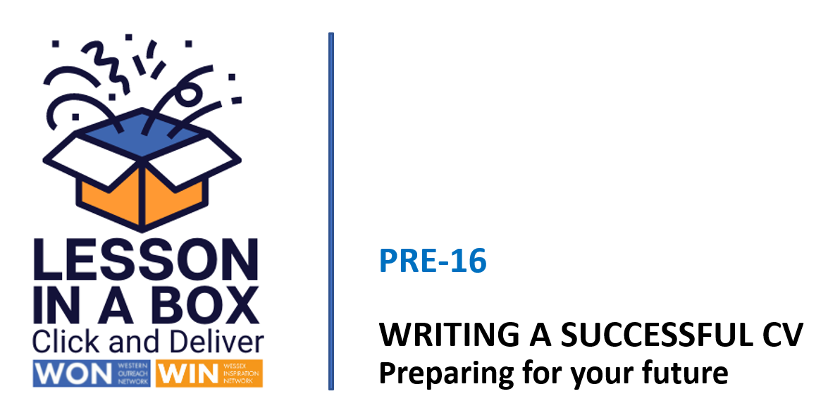

Delivery Notes - Session 2

Session | Time  25 minutes
Session Objectives:

- To identify personal skills and qualities.
- Understand why describing your hobbies and interests is important to an employer.
- To identify work-related activities.

Learning Outcomes:

1) Can describe and write three main skills and give an example from own experiences.
2) Can identify relevant hobbies and interests.
2) Can describe current work-related activities.

Resources

White Board
Teacher delivery via Power Point
CV template

Assessment/Pupil progress

Verbal feedback, response to Q&A, written tasks

Take-Home Task

Completion of CV

 | Time | Activity | Purpose
INTRODUCTION | 0-1 mins  2-3 mins  4-6 mins  6-10  mins | Slides 1/2/3  Welcome the students and introduce the session. Explain that this session will focus on the skills and work experience sections of their CV.  Give out CV template to class.  Slide 4  Hands up if - ask students to identify some relevant experiences for their CV  Slide 5  Show top skills slide. Ask students to map their experiences against these skills.  Slide 6  Ask students to complete the skills and personal qualities section of their CV | To reinforce those skills and experiences that will create a good CV  Identify extra-curricular activities and personal interests  Map experience and skills  To demonstrate how everyday experiences reveal transferable skills
DEVELOPMENT/CONCLUSION | 10-12 mins  12-17  18-23  24-25 | Slide 7  Watch video and discuss  Slide 8  Brainstorm activity - ask students to identify their own work-related activities  Slide 9  Ask students to list and describe their work-related experiences in the employment section of their CV  Slide 10  Play agree / disagree game - discuss results  Slide 11  Highlight relevant links and ask students to complete their CV’s  Please complete the teacher feedback form here | To understand how to include relevant hobbies and interests in a CV  To identify unique work-related experiences.  To complete work employment section of CV  To consolidate CV knowledge

