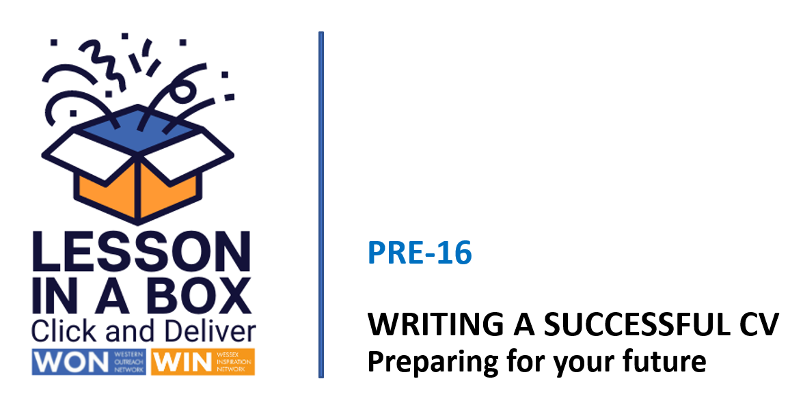

Delivery Notes - Session 1

Session | Time  25 minutes
Session Objectives:

- Explain what a CV is used for.
- Understand that a CV should highlight the skills, personal qualities, qualifications, interests, and experience a potential employer is looking for.
- Create a personal profile.

Learning Outcomes:

1) Can identify the structure and content of a good CV.
2) Can identify positive personal qualities and skills.
3) Can write a personal profile.

Resources

White Board
Teacher delivery via Power Point
CV template
All about me positive A-Z sheet

Assessment/Pupil progress

Verbal feedback, response to Q&A, written tasks

Take-Home Task

Research good and bad CV’s

 | Time | Activity | Purpose
INTRODUCTION | 0-1 mins  2-4 mins  4-7  mins | Slides 1/2/3  Welcome the students and introduce the session. Explain that we’re going to start to write a CV with a focus on personal skills and interests.  Give out CV template to class.  Slide 4  Class discussion - what is a CV for?  Slide 5  Read explainer slide. Ask students how long an employer looks at a CV before making a choice? Click to reveal.  Slide 6  Ask students to look at their CV template, discuss the different headings/content and structure and annotations.  Slide 7  Show explainer video to summarise introductory points. | Gauge student knowledge of the purpose of a CV  To demonstrate that a CV needs to have clarity and impact.  To demonstrate the structure and content of their CV, to explain that they’ll be focusing on their personal skills and qualities.  To summarise content, structure, and purpose of a CV.
DEVELOPMENT | 7-10 mins  10-14  14-16  16-21  21-23  mins | Slide 8  Introduce personal profile writing task, explain that this will evolve as students develop their own interests and skills and is a good foundation for self-promotion.  Slide 9  Distribute the All About Me positive A-Z sheet. Ask students to complete as quickly as possible going with their gut!  Slide 10  Ask students to identify their top 5 and describe themselves to a partner.  Slide 11  Read through slide and personal profile example, ask for feedback on the impression the example gives to an employer. Ask students to write their personal profiles in the space on their CV template.  Slide 12  Show examples of good personal profiles, ask students to identify the skills demonstrated – click to reveal. Can students improve their statements? | To understand the purpose of a CV personal profile.  To identify unique skills and qualities.  To articulate and share unique skills and qualities.  To write an effective personal profile.  To understand how personal experience and skills are demonstrated in a personal profile.
CONCLUSION | 23-25  mins | Slide 13  Show do’s and don’ts slides, discuss.  Please complete the teacher feedback form here | To emphasise that employers cannot ask for, or make decisions on date of birth, gender, orientation, marital status, religion, or nationality.

