
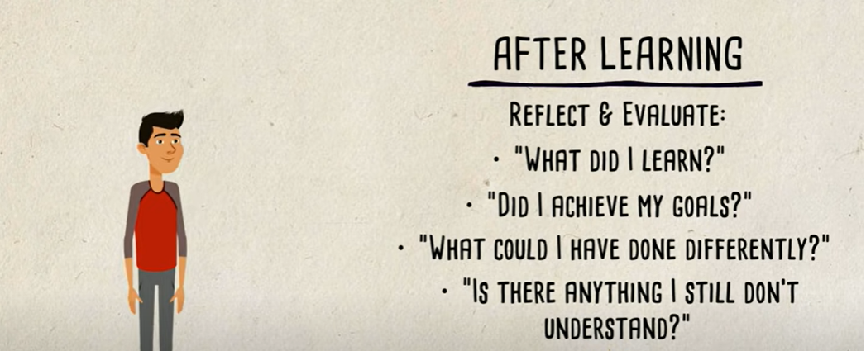
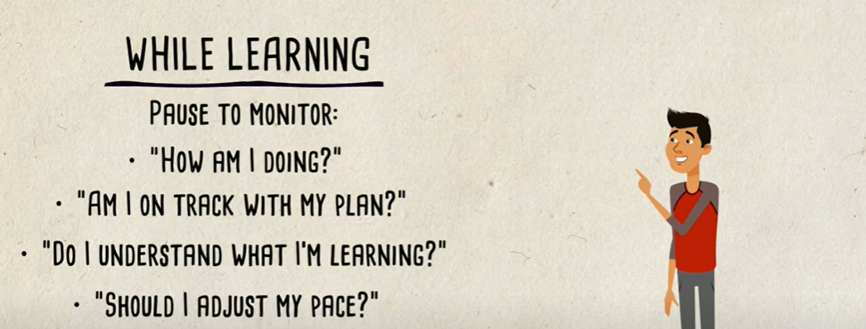
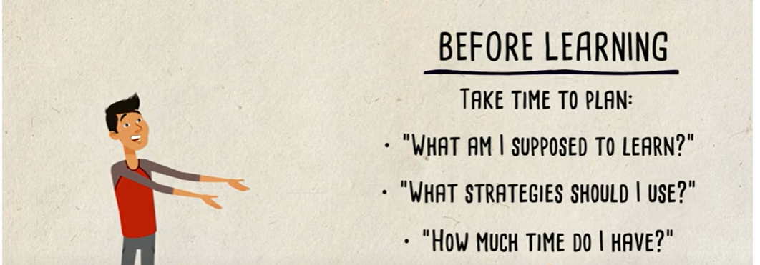

USEFUL WESBITES
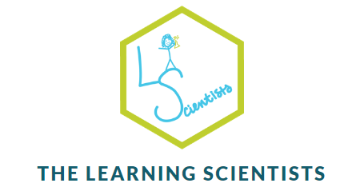

Time management
REVISION TIPS
METACOGNITION

Strategies
1.Feynman technique – learning through teaching
2.Spaced practice -review, practice, recall, formulate and synthesize the same materials multiple times.
3.Interleaving - mixing together different topics or forms of practice, in order to facilitate learning.
4.Elaboration - process of connecting or associating ideas or concepts in a meaningful way.
5.Retrieval practice - engage with the material in an active way rather than passive learning i.e. testing knowledge.
6.Concrete examples - a way to make an abstract idea more meaningful
7.Dual coding - Using visuals alongside information

