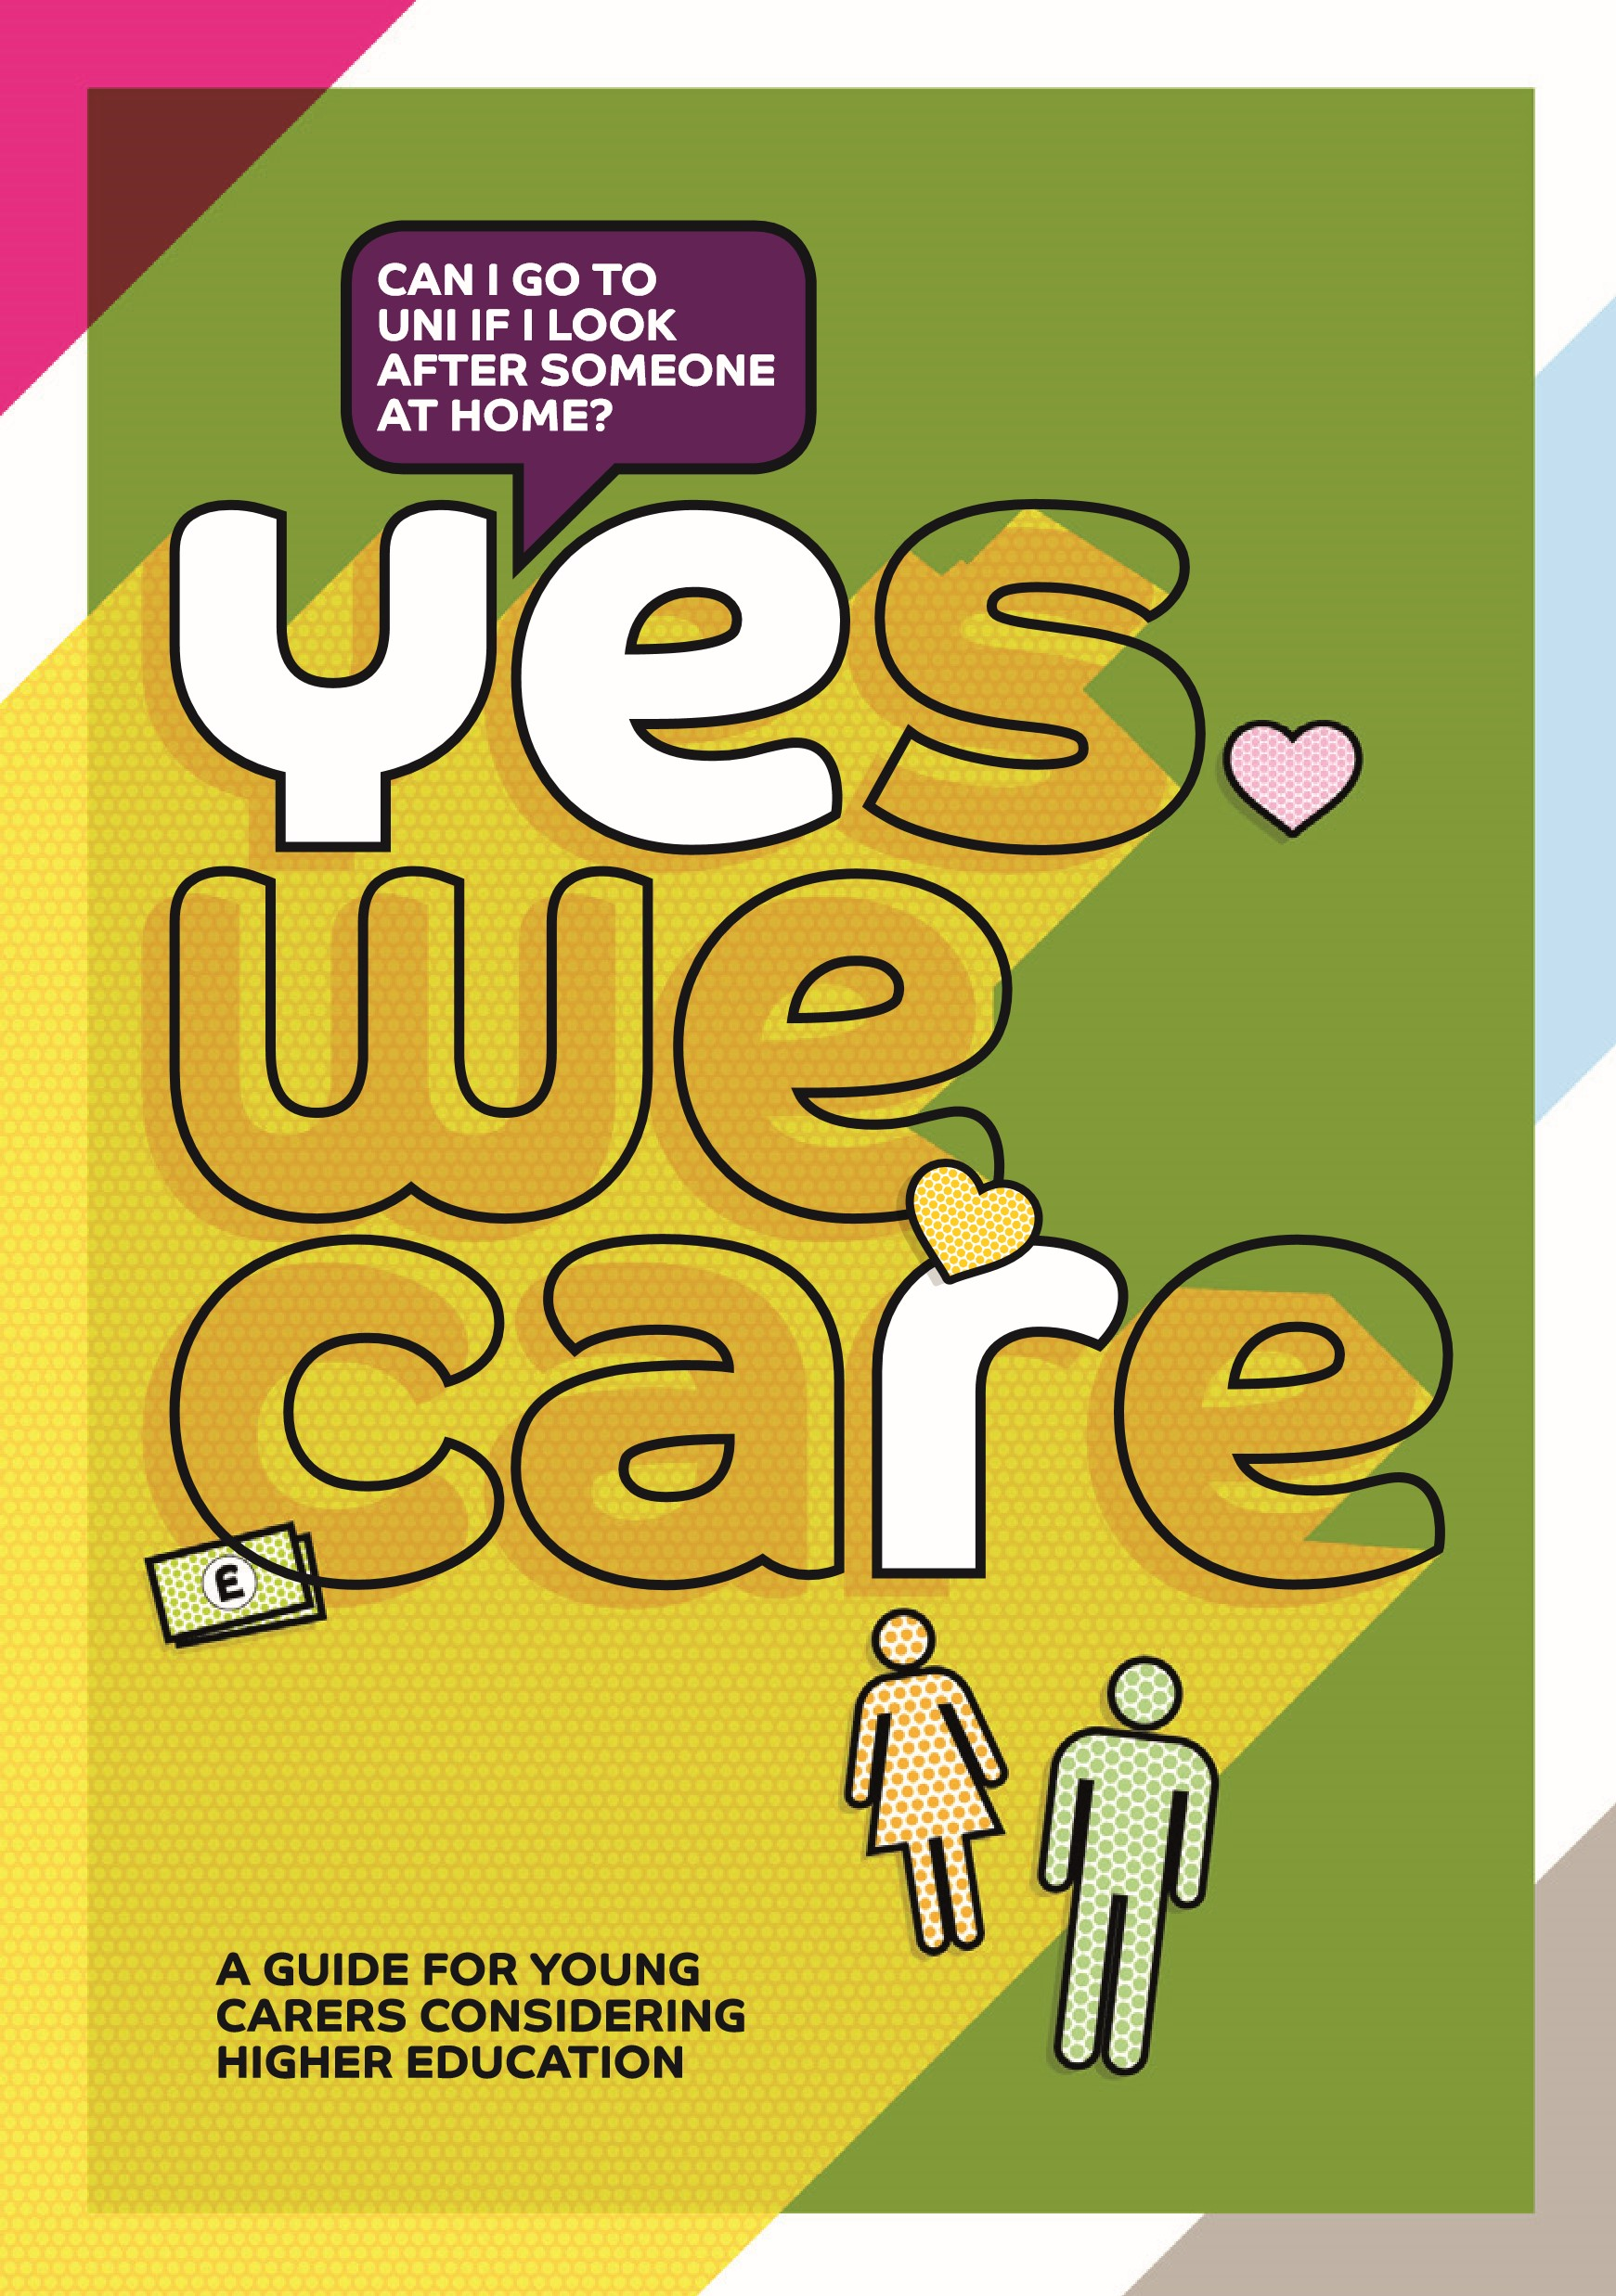
WHAT’S IN
THIS GUIDE?
HELP WHEN YOU’RE AT SCHOOL
Links and information on getting support at school.
Page 4
HELP WHEN YOU’RE IN

SIXTH FORM OR COLLEGE
Information on local schemes to help.
Page 5
CARING ABOUT YOU
Answers to some of the questions

and concerns you may have.
Page 7
WHAT NEXT?
Tips to help you take your next steps
towards higher education.
Page 12
CONTACTS
Find out where the local higher education providers

are and how to get in touch with them.
Page 14
IS THIS BOOKLET
FOR ME?
Are you a young person who looks after someone who has
• a long term physical illness?
• a physical or learning disability?
• mental health problems?
• drug / alcohol problems?
If you are and you’re thinking about higher education, then this booklet
is definitely for you.
Going to university or college can open up many more career
opportunities to you. You can gain the skills you need to help you
achieve your dream job and earn more money in your adult working life.
A degree also gives you the chance to make lasting friendships, adapt
more quickly to a changing world and have greater confidence.
Higher education might not be for everyone but your caring
responsibilities should never prevent you from realising your ambitions.
It’s a big decision to make, so knowing what help is out there can make
you feel more confident.
This booklet will tell you about the support you can get to help you
achieve your higher education goals and how other young carers
currently studying for a degree feel about higher education.
We care about you
Do you help to look after someone at home?
Are you thinking about your future?
Uni could be for you!
HELP WHEN YOU’RE
AT SCHOOL
If you think you’re a young carer and would like
more support, the best thing to do is let someone
know. Lots of schools and colleges have great
support for young carers but if they don’t know
they can’t help.
You can also get a
Young Carers Assessment
to help you get
support. This is a way for you to tell a worker about your caring,
so you can plan things together that will make your life easier.
For more information, contact your local council and ask about
getting a young carers assessment.
Deciding whether and where to go to university - and what subject
to study - are big choices to make. Most schools will have links with
universities to give you the chance to find out more, visit a university
or hear from staff and students visiting your school.
You can also get help from your local young carers service.
Search online to find one near you.
It’s your choice, but telling
people about your caring role
means you can access more
help and support.
HELP WHEN YOU’RE
IN SIXTH FORM OR COLLEGE
Getting into higher education can feel difficult if you also have caring responsibilities at home. Lots of universities and colleges offer schemes to help young carers get there – in Sheffield this includes:

The Compact Scheme at Sheffield Hallam University
Compact provides extra support if you face barriers to going to university, including if you have caring responsibilities. It’s available when you apply to Sheffield Hallam University and you’ll be able to
get in touch with a named contact for all your enquiries and questions go on exclusive visits to the university receive emails about Sheffield Hallam life receive help with interviews for higher education
r eceive special consideration during the admissions process
(in exceptional circumstances only)
For more information contact the Compact team on 0114 225 4231 or email compact@shu.ac.uk.

Discover-Post 16 Outreach at the University of Sheffield
The Discover programmes give participants the opportunity to find out what it’s like to study and work in subject specific areas across the whole University. These include medicine, law and many others. Each of these programmes also provide practical help with study techniques, application support and an introduction to life at the University. If you’re accepted onto the scheme you’ll receive an adjusted offer of up to two grades lower than usual.
For more information contact the Outreach Team on 0114 222 1027 or email outreach@sheffield.ac.uk.
If you want to study outside Sheffield, ask any university or college what they do for young carers. They probably run similar schemes too.

Sarah, studies Primary Teaching
“Before I applied to uni, I was worried about them not being flexible if I needed to stay at home with my mum and about how I’d keep up with the workload with everything going on at home. And once I started, everyone was talking about going out for Fresher’s Week but I just wanted to be at home – it felt like ‘who will be my friend if I don’t go to fresher’s nights out?’.
But the fact that I could state I was a carer when I applied helped me to know they were thinking about us carers. They added me to a carers Facebook group before I started, so I knew there were other student carers and that I had a way to message uni staff who are there to help us. They did a group chat session so people could ask questions and get help. My lecturers know I’m a carer too and they let me pop out to answer my phone if I need to, which helps me feel more relaxed.
My advice is to tell someone you’re a carer before you start uni so you get the support you need straight away. And try not to worry – I’ve been able to do it – you can too!”

Sarah’s mum Bev
”Before Sarah started, I felt really anxious because I panic when I’m on my own and Sarah was my main support. I was worried how she’d cope too.
Sometimes when I’m really low she doesn’t want to leave me and that makes me feel guilty. But I feel really positive now. She’s completed her first year and I feel so proud of her – in spite of everything, she’s managed really well and got really good grades.
If you’re a parent worried about your son or daughter going to uni, my advice is to talk to someone. It can be really hard to ask for help but don’t sit in silence. You’d be surprised how many people offer help if you actually ask for it!”
CARING ABOUT YOU
Do I have to tell anyone I’m a young carer
when I apply to college or university?
It’s always your decision, but it could definitely benefit you if you do.
Universities and colleges often have lots of support for young carers,
including personal support or financial help. If they know about your
caring responsibilities, they could tell you this before you arrive, so
it feels less scary and more manageable. Being a young carer will
also give you lots of useful experiences and qualities that make your
application stronger.
Y ou can write about your caring role to support and enhance

your personal statement.
Y ou can tick a box on the UCAS form (by 2018) to show

that you are a young carer.
I f you feel your caring role has impacted on your Year 13 exam

results, you can let the university or college know and they may
be able to give you extra consideration.
When I was applying to university I looked
to see if there was any support on offer for
carers in case I needed to get things off my
chest. I told Sheffield Hallam about my caring
responsibilities in my interview and I was

offered support from the start.
My advice to anyone with caring responsibilities

who is considering applying for university would be

to go for it, don’t underestimate yourself. There will

always be someone to help and support you.
Autumn-Rose, studies Nursing
CARING ABOUT YOU
How can I afford to care and study at the same time?
Many universities and colleges offer financial help for young carers,
to help you with the costs of studying, transport or arranging some
respite care. These are often called bursaries, grants or scholarships.
They are totally different to loans because you don’t need to pay
them back
. They can make a real difference to your daily routine. For
example, the University of Sheffield currently gives carers
£4,500
per
year of study (2017 entry). Check before you apply to the university
you are interested in.
The bursary does help a lot with travel
expenses. Sometimes my mum will
ring me late at night, and I know I can
afford to travel back home to see her
and make sure she’s okay.
My advice would be to do your
research about what support your
universities are offering. Make sure
you are realistic about your goals and
aims but do not let the caring hold
you back.
Josh, studying Economics with Finance
Lives away from home
Help with being away from home
The idea of leaving the person you care for can be worrying,
whether you go into university for classes during the day or if
you choose to move away to study.
But you have the right to
study if you want to.
Some ways to help this feel easier could be
c ontacting your local city council to request a carers assessment,
so they know your home situation is changing and can check
your family are getting the right support so you can study
c ontacting your local young carers or adult carers services to see
if they can offer any advice
s peaking to staff at the university you want to apply to - if they
know you are a carer, they will know that sometimes you might
need to rush home for emergencies.
CARING ABOUT YOU
What if something goes wrong
while I’m studying?
Caring is part of everyday life and it can be really rewarding.
You may find you cope really well most of the time, but
sometimes it’s good to know where to get help if you need
it. For example, if the person you care for urgently needs you
while you are away from home. Wherever and whatever you
study, there will be someone available to give you the time
and space you need to talk things through.
You are the expert in your life and we’re
ready to listen, whether you need help
planning your studies, emotional support,
or emergency help.
Young carer advisers at a local university
You’ve always got support.
Your lecturers will give you
extensions if you need it.”
“A lot of people who are carers
think it can’t be done. I went
through a phase when I thought
‘I can’t manage university and
caring at the same time’. But I did

it and I think a lot of people can
also do it. I think we can do it!
Asma, studies Health and Human sciences
Lives at home
Studying for a degree is a great experience
that can change your life.
To make sure you benefit…
1

Do your research.
Every university and college is different and
many offer help to young carers before you even start studying
there. Make sure you find out what support you can get.
2

Go to open days.
If this is difficult because of caring, find out if
the university or college can offer financial help towards travel
costs or see if you can speak to someone on the phone or arrange
a separate visit instead.
3

Work hard to get the best results you can.
If you haven’t
already, let someone at school or college know about your caring
so they can support you to achieve your best.
4

Had a crisis during your exams?
Call the university or college
to let them know. They might be able to take this into account.
5

Be proud about being a young carer.
It’s an amazing thing you
do and it will have taught you a lot. It could also really help your
personal statement if you include the skills and experience
caring has given you.
6

Go into higher education and get the funding, degree
and career that you deserve!
WHAT NEXT?
They all did it
– you can too!
Many thanks to all the young carers, school
staff, and staff at Sheffield Young Carers for their
contribution to the development of this booklet.
Our special thanks goes to Autumn-Rose, Asma,
Josh, Sarah and Bev for sharing their stories.
If you want to know more about some of their
experiences, watch the young adult carers

video on the University of Sheffield Outreach

YouTube Channel.
CONTACTS
Universities and colleges have specially
trained advisers who can provide support for
young carers. You can usually find them within
the Student Services teams. Have a look at
our website www.yeswecare.uk for more
information on how to find them.
Barnsley College

studentservices@barnsley.ac.uk
University Campus Barnsley
studentservices@barnsley.ac.uk

Chesterfield College
studentservices@chesterfield.ac.uk

Dearne Valley College
learn@dearne-coll.ac.uk
Doncaster College

financial.support@don.ac.uk
University Campus Doncaster
financial.support@don.ac.uk
Northern College

studentservices@northern.ac.uk
North Nottinghamshire College
contact@nnc.ac.uk
Rotherham College

info@rotherham.ac.uk
Sheffield College

studentservices@sheffcol.ac.uk
Sheffield Hallam University

care@shu.ac.uk

The University of Sheffield
support@sheffield.ac.uk
Other support services
There are many other support services available for young carers.
Please visit our website
www.yeswecare.uk

to find your local service for
your area, as well as links to online sources of information and support.
15
The University of Sheffield

www.shef.ac.uk
Barnsley College

www.barnsley.ac.uk
Northern College

www.northern.ac.uk
University
Campus Barnsley

www.barnsley.ac.uk/ucb
Dearne Valley College

www.dearne-coll.ac.uk
North
Nottinghamshire
College

www.nnc.ac.uk
Rotherham College

www.rotherham.ac.uk
Sheffield Hallam University

www.shu.ac.uk
Sheffield College

www.sheffcol.ac.uk
Chesterfield College

www.chesterfield.ac.uk
Doncaster
College
www.don.ac.uk
University
Centre Doncaster
www.don.ac.uk/
universitycentre
BARNSLEY
DONCASTER
SHEFFIELD
ROTHERHAM
BASSETLAW
BOLSOVER
CHESTERFIELD
DERBYSHIRE
DALES
NORTH EAST
DERBYSHIRE
MAP KEY OF SHEFFIELD
CITY REGION
Higher education
Further education
Both

