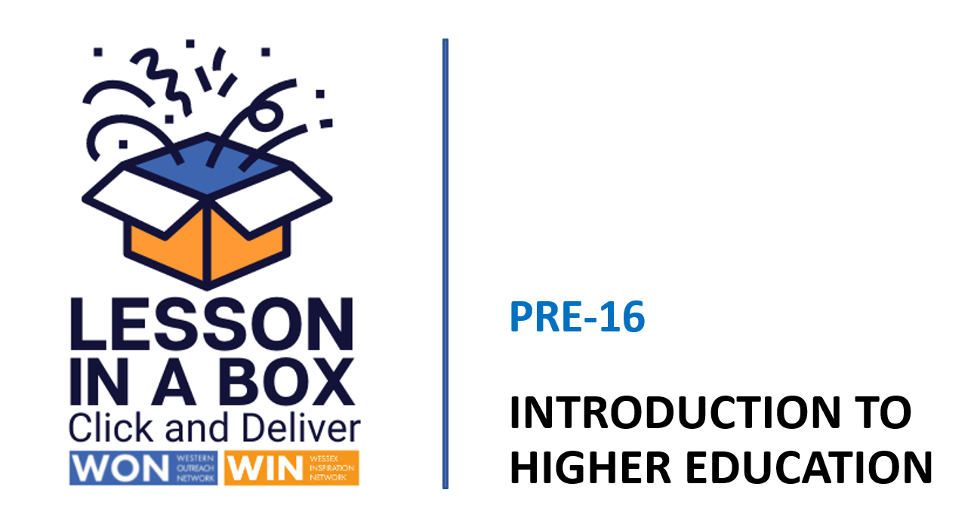

Tutorial Delivery Notes
Session 2

Session 1 | Time  25 minutes
Session Objectives:

- What skills can I develop to help me progress to Higher Education?
- What course could I possibly do after school or college?
- How will I learn at university?
- How will I apply to university?

Learning Outcomes:

1) Can identify current passions and interests.
2) Can understand the varied career options from three different degrees.
3) Can understand the differences and similarities between a lecture and a lesson.
4) Can have a basic understanding of the UCAS application process.
5) Can begin to consider next steps.

Resources

White Board
Teacher delivery via Power Point

Take-Home Task

Suggest searching the student section of the WIN website for more information.
Students > What is Higher Education (HE)? — Wessex Inspiration Network (WIN) (winncop.ac.uk)

 | Time | Activity | Purpose
INTRODUCTION | 0-4 mins  4-7 mins | Slides 1/2  Welcome the students and introduce the session.  Slide 3  Ask students why they think it’s important to think about Higher Education now?  Slide 4  Explain that hobbies and interests support self-development and will help when applying to university. Ask students to play the STAND UP IF game and click to reveal the categories.  Reassure students if they can’t identify something now this may give them inspiration to start something new.  Slide 5  Ask the students to work in pairs, choose two questions to ask each other, and feedback to the class.  Slide 6  Stress to students that it is more reassuring and open minded to ask themselves what they could POSSIBLY do rather than what they WANT to do. | Understand the importance of  self-development  when considering progression to HE.  To begin to understand how developing passions and interests help when applying to university.
DEVELOPMENT | 7-14 mins  14-18  mins | Slide 7  Ask students if anybody already has a subject they would like to study further?  Slide 8  Discuss top ten courses.  Slide 9  Ask what jobs are available if studying the three subjects?  Slide 10  Reveal answers and discuss.  Slide 11  Focus on ASPIRATION and the possibility of becoming an expert in a specialist subject and obtaining a PHD.  Slide 12  Show video. Ask students if they know anyone who has a PHD?  Slides 13/14  Introduce the concept of learning lecture style. Ask students to watch the video and identify the main differences and similarities between learning at school and university. | To understand the jobs available when studying certain degree subjects.  To understand what a PHD is how you study for one.  To understand the differences and similarities between learning at school and university.
CONCLUSION | 18-25  mins | Slides 15/16  Remind students that there’s lots more to university life than attending lectures.  Show examples of clubs and societies, ask students if they can come up with their own? Why would they attend it?  Slides 17/18  Introduce the students to UCAS, the application process and the fact that they will write a personal statement if they apply. Click on the link to reveal the range of courses on the UCAS website.  Slides 19/20/21  Conclude with a class discussion based on the questions  Slide 22  Ask students to make a note of the websites they can search for more information. Remind them to ask those around them for their experiences.  Slide 23  Ask agree/disagree questions. Discuss with the class in relation to considering their next steps/identifying their future pathway.  Slide 24  If you have time at the end of the session you may like to show students, our  Connect to You film (running time 3mins) which focuses on self-acceptance, inspiration, and aspiration.  WIN Connect to you - YouTube  Slide 25  Please complete feedback form.  WIN Lesson in a Box - Staff Feedback (Page 1 of 2) (office.com)  THANK YOU. | To understand the breadth of university life.  To understand that you apply to university through UCAS.  To begin to consider next steps/future pathway and look and ask for help and advice.

