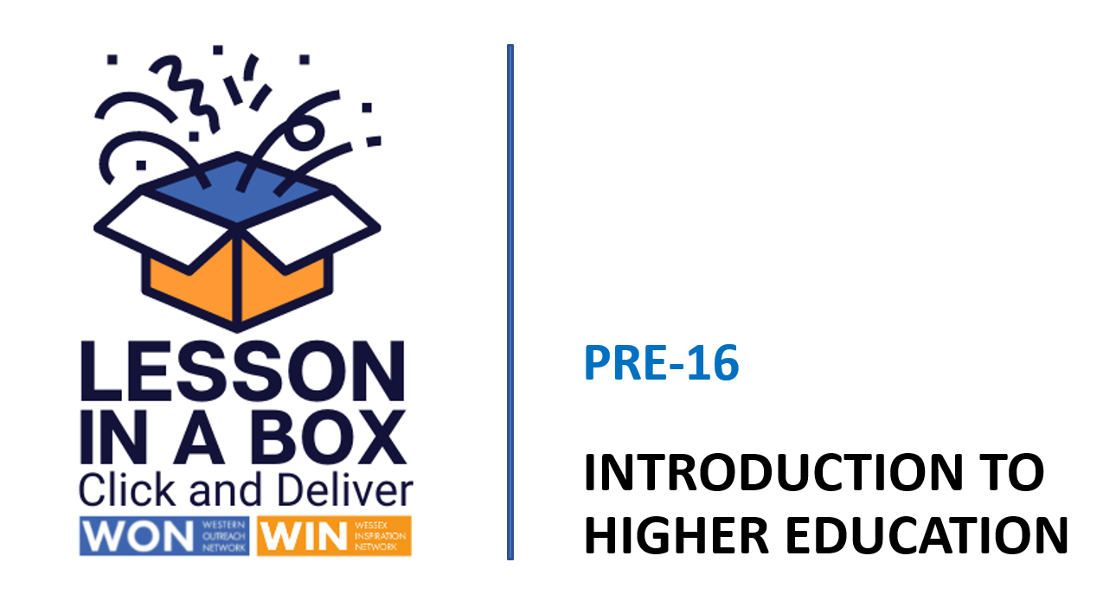

Tutorial Delivery Notes
Session 1

Session 1 | Time  25 minutes
Session Objectives:

- What is Higher Education and how do I get there?
- What could I possibly do after school or college?
- Can I begin to identify the steps I need to take to achieve my goals?

Learning Outcomes:

1) Can identify what a graduate is.
2) Can identify where they are on a progression path and the different
options available.
3) Can identify the different types of university and living situations.

Resources

White Board
Teacher delivery via Power Point

Assessment/Pupil progress

Verbal feedback and response to Q&A

Take-Home Task

Suggest research into Higher Education, different types of university and available courses.

 | Time | Activity | Purpose
INTRODUCTION | 0-4 mins  4-7 mins | Slides 1/2  Welcome the students and introduce the session.  Slide 3  Ask students if they can think of any other questions that could go in the speech bubbles?  Slide 4  Ask for a show of hands to gauge prior knowledge - record results.  Slide 5  Discuss the photograph, who is in the picture? What is happening? What are they wearing?  Slide 6  Show explainer video.  Ask students if they can now define what  HE is?  Can they name some employability skills they’ll learn if they progress to HE? | Gauge prior knowledge/  understanding of HE.  To understand ‘University Level’ study.
DEVELOPMENT | 7-10 mins  10-15  mins | Slide 7  Ask students questions - can they guess the answers? Click to reveal.  Slide 8  Talk through explainer slide.  Slide 9  Introduce the concept of progression  Slide 10  Emphasise that learning is life-long and that they may come back to learning or complete a degree or further study later in life.  Slide 11  Talk through the slide and discuss the different learning options available at each level. Emphasise that you can do an apprenticeship and gain a degree and talk through the progression from BA to MA to the possibility of gaining a PHD.  Slide 12  Click to reveal that students will receive help from a qualified careers advisor.  Slide 13  Click on link to discuss to enter postcode and see the variety of Apprenticeships available in your local area.  Slide 14  Show video and ask if an apprenticeship is something that now appeals to students?  What do they think would be the best thing about being an apprentice for them? | To understand how many universities and courses there are in the UK.  To understand different pathways and qualification options available at different levels.  To understand what an apprenticeship is and how to choose one, depending on their area of interest.
CONCLUSION | 15-25  mins | Slide 15  Ask students if they can think of any other questions that could go in the speech bubbles?  Slide 16  Show university map of the UK and click on link to show the full A-Z list.  Slide 17  Describe the different types of university and click on Student Room link to explain further.  Slide 18  Explain that we are now going to focus on looking at a campus university. Show video.  Ask students if there’s anything that surprised them whilst watching it?  Slide 19  Based on the film and their new knowledge of university ask the students where the photos were taken?  Answer - in and around Halls of Residence.  Slide 20  Please complete feedback form.  WIN Lesson in a Box - Staff Feedback (Page 1 of 2) (office.com)  THANK YOU  Slide 21  Thank students for participating and remind them that the next session will be on how and what they will learn at university. | To understand where UK universities are located, what a university looks like and can differentiate between the different types.  To understand what a campus university Is and what is available on site.  To understand the living situation on campus and in Halls of Residence.

